Methodological recommendations

Political conflictology

Recommendations
on organizing independent work
The forms of independent work are determined by the content of the academic discipline, are closely related to the topics of lectures and seminars, and are of a research nature.
In the first week, we will conduct an orientation consultation, where the tasks of the SRO organization will be formulated in detail. Then you will move on to the performance and search cycle, where you will begin to complete tasks on the topic. You will work with library resources, prepare presentations, and develop a conflict map. We hope that you will demonstrate a high level of independence, search activity, and will find creative ideas for resolving conflicts.
It is mandatory to work with all the main literature indicated in the Syllabus.
The SRO must be independent and creative in nature.
Plagiarism, forgery, and the use of cheat sheets are not allowed at all stages of the SRO.
Mandatory compliance with deadlines for completing and submitting assignments. Failure to meet deadlines results in loss of points! The deadline for each assignment is specified in the calendar (schedule) for the implementation of the course content.

ISW - 1 (essay) on week 3 25 points
Methodological recommendations
An essay (from the French essai - “test”, “sketch”) is a prose study (composition) that presents general or preliminary thoughts on some subject or on some occasion.
The purpose of the essay is to reveal your ability to independently and comprehensively express an opinion in writing (based on certain sources or scientific literature) on a specific issue.
The essay genre allows for freedom of creativity; it can be written in any style, since an essay is your personal reflection on what you have heard, read, or seen.
For a competent, interesting essay, it is necessary to follow some rules and recommendations:
1. In the foreground of the essay is your personality as an author, your thoughts, feelings, attitude to the world. This is the main setting of the essay. However, it is important to remember that, despite the freedom of creativity, writing in the essay genre is not at all easy, since you need to find an original idea (even on traditional material), a non-standard view of some problem.
2. Imagery, paradoxicality, aphorism - these are the main distinctive features of the essay style. To convey personal perception, mastering the world, the author of the essay selects analogies, uses numerous examples, draws parallels, uses all sorts of associations.
3. The construction of an essay is an answer to a question or disclosure of a topic, which is based on the classical system of evidence.
Essay structure:
1. Title page.
2. Introduction - the essence and justification for the choice of this topic, consists of a number of components that are connected logically and stylistically. At this stage, it is very important to correctly formulate the question to which you are going to find an answer in the course of your research. When working on the introduction, answers to the following questions can help: "Is it necessary to give definitions of terms,
", "Why is the topic I am covering important at the moment?", "What concepts will be involved in my discussion of the topic?", "Can I divide the topic into several smaller subtopics?"
3. The main part - the theoretical foundations of the chosen problem and the presentation of the main question. This part involves the development of argumentation and analysis, as well as their justification, based on the available data, other arguments and positions on the proposed question. This is the main content of the essay and this is also the main difficulty. In the process of constructing an essay, it is necessary to remember that one paragraph should contain only one statement and the corresponding evidence, supported by illustrative material. Therefore, filling the sections with content argumentation (corresponding to the subheadings), it is necessary to limit yourself within the paragraph to considering one main idea.
4. Conclusion - generalizations and reasoned conclusions on the topic, indicating the area of its application, etc. Summarizes the essay or once again provides explanations, reinforces the meaning and significance of what was stated in the main part. Methods recommended for drawing up a conclusion: repetition, illustration, quotation, impressive statement. The conclusion may contain such a very important element that complements the essay as an indication of the application (implication) of the study, without excluding the relationship with other problems.
Source: “Rules for writing essays” http:wiki.vgipu.ru/images

ISW - Study the indicators of political tension ( Presentation ) Week 7 25 points
Recommendations for preparing a presentation:
Make a plan for your speech
Plan your presentation time
Be sure to visualize the information
Don't put too much information on a slide.
Only put information on a slide that you intend to refer to.
Make a timeline
For COMPARISON, use appropriate charts (e.g. two-sided bar chart)

Reveal the role of the media in resolving international conflicts (abstract)

Develop your own tactics for third party interaction with opponents in resolving an international conflict

What are the internal causes and prerequisites of “color revolutions” and the conditions under which they can manifest themselves? (essay).

ISW 3 Prepare a conflict analysis map (see conflict analysis map) Week 11 25 points

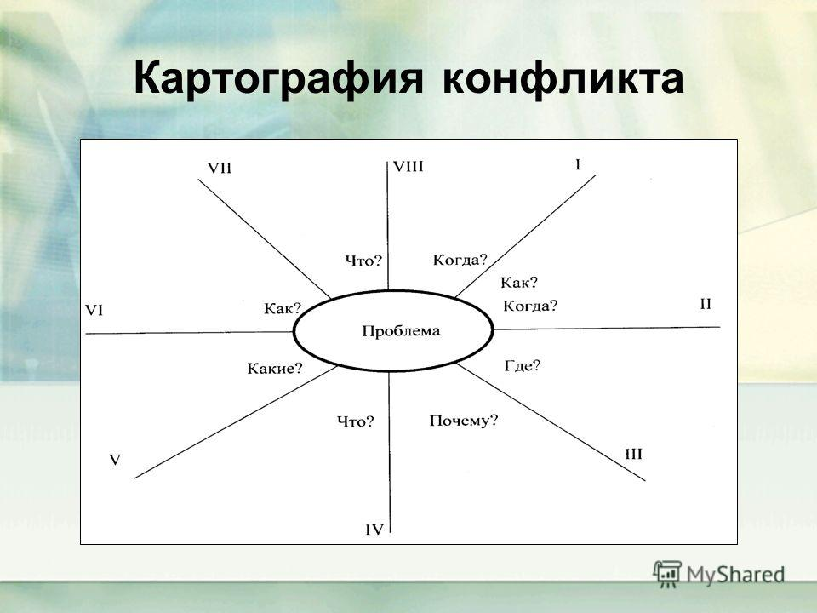
The main stages of management activities for the prevention and resolution of conflicts

Stages | Procedure | Operations
Stage 1 Conflict diagnostics | Procedure 1.1  Collecting primary information about the conflict | Operation 1.1.1  Determining the main directions for collecting the necessary information  Operation 1.1.2  Selecting a collection method  Operation 1.1.3  Prioritizing problems by severity
Stage 2 Transformation of the conflict situation | Procedure 2.1  Identifying possible transformation paths  conflict situation  Procedure 2.2  Organizing group work to change conflict | Operation 2.2.1  Creation of an initiative group of independent experts on conflict prevention  Operation 2.2.2  Organization of negotiations between conflicting parties
Stage 3  Conflict resolution | Procedure 3.1  Organization of work on conflict resolution | Operation 3.3.1  Determining ways to resolve the conflict

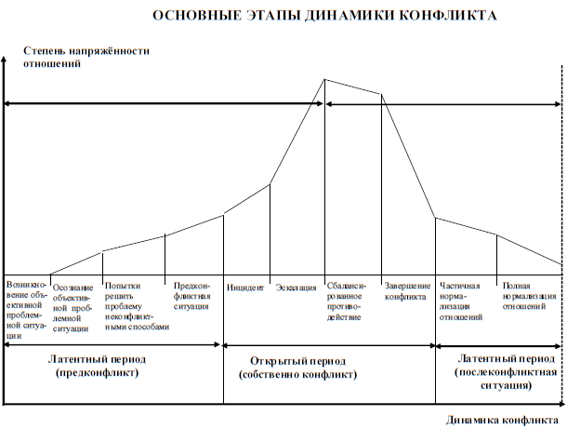

Aggression is a form of behavior of participants in a conflict aimed at causing physical or psychological harm, at destroying another person, a group of people, or large social communities.
Arbitration is a method of resolving conflicts in which the parties appeal to arbitrators elected by the parties themselves or appointed with their consent, or in accordance with the procedure established by law.
War is a social conflict of the highest intensity, one of the forms of resolving socio-political, economic, ideological, as well as national, religious, territorial and other contradictions between states, peoples, nations and social groups by means of armed violence.
The boundaries of a conflict are spatial and temporal frameworks beyond which there is no minimum of structural elements of the conflict that ensure its existence as an integral system.
Conflict diagnostics is an activity to determine the essence and characteristics of a conflict based on its study, as well as a set of principles, techniques and methods for studying the conflict. Conflict diagnostics consists of developing descriptive, evolutionary-dynamic and explanatory models of the conflict.
An incident is an event that serves as a “detonator” of a conflict, a formal reason for open conflict interaction.
Institutionalization of political conflict is the process of formation of political and non-political institutions, a system of norms, values, and attitudes capable of regulating the behavior of citizens in a conflict situation.
Zero-sum conflicts are conflicts in which the parties' positions are opposite, and therefore one party achieves its goal at the expense of the other.
Non-zero-sum conflicts are conflicts in which a compromise is reached on a mutually beneficial basis.
An interstate conflict is a special political relationship between two or more parties – peoples, states or a group of states – that concentratedly reproduces, in the form of an indirect or direct clash, economic, social-class, political, territorial, national, religious or other interests by nature and character.
Non-institutionalized political conflicts are aimed at destabilization, weakening the political system and its institutions, overthrowing the existing political regime or radically changing the political course.
Negotiations are a way to overcome conflict contradictions, a dialogue between the parties with the aim of resolving the conflict.
Negotiation space is the area of the subject of the dispute where agreement can be reached.
Political conflictology is the science of the causes, forms, structure, dynamics and ways of resolving political conflicts.
Political conflict is a special type of social conflict, which is distinguished on the basis of the specificity of the sphere to which the content of the contradictions between the conflicting parties and the subject of the dispute relates. The subject of political conflict is made up of specific resources in the sphere of politics – state power, the principles and mechanisms of its distribution and implementation, the structure of power institutions, the priorities of state public policy, the political status of social groups, the values and symbols that are the basis of political community, etc.
Political behavior is a set of reactions of social subjects to the activities of the political system.
Conflict preventers are components of a system of measures and mechanisms that can suppress or minimize the threat of the emergence and development of causes of destructive, primarily violent, conflict.
Conflict prevention implies a comprehensive neutralization of all factors and conditions that determine an emerging conflict, which allows for the interaction of subjects to be directed towards their cooperation in the name of realizing their shared interests.
Prevention of destructive conflicts is an activity aimed at limiting or preventing the escalation of a conflict in order to avoid its destructive, primarily violent, manifestations.
Resolution of a political conflict is the elimination of the causes that gave rise to the conflict, that is, the elimination of the conflict of interests and goals of the opposing parties.
Conflict management is an activity at the macropolitical level that means establishing certain institutions, procedures and practices within the political system for managing recurring conflicts. In addition to managing individual conflicts, regulation also includes activities to prevent destructive forms of conflict manifestation.
Settlement of political conflict – partial resolution of political conflict, termination of open form of struggle of conflicting parties. At the same time, internal reasons, prompting to conflict, may remain.
Facilitation is a type of mediation, the participation of which is often limited to providing assistance to the parties to the conflict in organizing negotiations. The main content of this model of mediation is to direct the parties to the conflict to use technologies that facilitate the settlement of contentious issues.
Conflict escalation is an increase in the severity and scope of a conflict, associated with an exacerbation of the emotional background of the conflict, a demonstration of force, and the use of violence, which only aggravate the conflict and expand its spread.

